NSF Spatiotemporal Innovation Center
Center for Geographic Analysis
Open opportunity to work as an NSF REU Fellows from May to September 2023 at either Harvard University or George Mason University. The NSF's Spatiotemporal Innovation Center is offering an excellent opportunity for any undergraduate student interested in spatiotemporal domains, such as computer science, geographic information systems, and geosciences.
NSF REU Fellow students will gain real-world research experience, work with professionals in the field, and expand their network of connections. It's a fantastic opportunity for students to explore different areas of research and gain valuable skills. The program is funded by the NSF I/UCRC and REU Programs, enthusiastic undergraduate students will gain research experience that can help them consider future career paths in their chosen field.

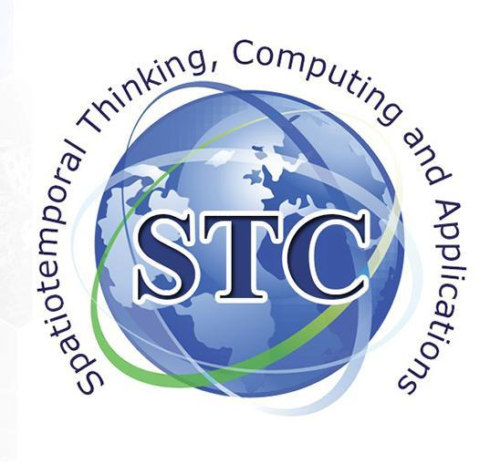
February 2023 Monthly Newsletter
Edited by Seren Smith & Shyra LaGarde
Content provided by Wendy Guam, Seren Smith, Phil Yang, & Shyra LaGarde
Designed Yun Li, Ziyue Xu, & Seren Smith

https://www.google.com/url?sa=i&url=https%3A%2F%2Fstock.adobe.com%2Fsearch%3Fk%3Dtechnology%2520back ground%2520green&psig=AOvVaw2RTVzmfocrorlYtkhw8zcB&ust=1645380876183000&source=images&cd=vfe&ved=0CAsQjRxwoTCPjDgJuwjPYCFQAAAAAdAAAAABAD
February 2023

The STC Center has published a new book chapter titled “ArcCI: A high-resolution aerial image management and processing platform for sea ice” published in GSA.
Two START Interns presented at Georgia's State Capitol
The Spatial Data Lab's sponsored workshop offers an opportunity to professionals with a background in geographic analysis. Interested applicants must submit a CV and a 300-word research project abstract via the provided link by March 1, 2023, and are responsible for their own travel and lodging expenses.
Wendy Guan from Harvard's Center for Geographic Analysis discusses her background in geospatial analysis and their partnership with KNIME to make geospatial data accessible to non-experts through the Geospatial Analytics extension.

The Summer Workshop on Spatiotemporal Innovation

Spatial Data Lab's sponsored workshop aims to advance spatiotemporal data science with innovative methodology and technology. Attendees will learn about workflow-based tools, functions, and case studies in fields such as public health, business, social media, remote sensing, and environmental science. This workshop will also feature a symposium for participants to present their research and network with fellow professionals. Don't miss this chance to enhance your domain knowledge and leadership skills.

Preference will be given to applicants with a background in geographic analysis, and participants will be required to complete a group project and present their findings at the symposium. Completion of the program and group project will earn participants a certificate, and outstanding participants will be invited to join the Spatial Data Lab project.

To apply, submit a CV and a 300-word research project abstract via the provided link by March 1, 2023. Accepted applicants will receive further information and are responsible for their own travel and lodging expenses. Contact spatialdatalab@lists.fas.harvard.edu for questions. Visit site for more information.

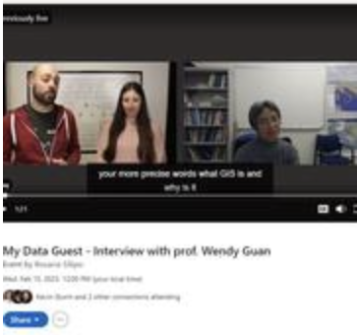

Online KNIME interview with Wendy Guan on Geospatial Analyst Extension
On My Data Guest, Wendy Guan, Executive Director of the Center for Geographic Analysis at Harvard University, discusses her background in geographic analysis and experience managing professional services at a GIS consulting firm and heading the geospatial information technology department for a multinational forestry corporation. Harvard's Center for Geographic Analysis has partnered with KNIME to make geospatial data accessible to non-experts. The Geospatial Analytics extension allows users to access, blend, and analyze geospatial data using nodes that are easy to understand and work with. This collaboration is an exciting development for those interested in geospatial data analysis, as it provides a more user-friendly and efficient way to work with this type of data.

Shyra LaGarde, Georgia Legislator, Alexander Fouraker
Book chapter titled 'ArcCI: A high-resolution aerial image management and processing platform for sea ice" published in GSA
The Arctic sea-ice region is a crucial area for studying climate change. ArcCI is a Cloud infrastructure solution that supports Earth science by providing efficient and accurate extraction of geophysical features and spatiotemporal analysis of sea-ice leads. The ArcCI system employs an object-based image analysis method and machine learning classification approaches to manage and process high spatial resolution imagery on-demand. This helps scientists better understand changes in the Arctic sea-ice region.
Two START Interns present at Posters at the Capitol.
Georgia's State Capitol Showcases Researchers talents: Two Undergraduates Stand Out with Research on Vehicle Speed and COVID-19 Surges. The competition this year was extremely tough as there were approximately 90 applicants and only 38 were chosen from all the colleges/universities in the state.
Alexander Fouraker presented a collaborative study with Valdosta smart city and Georgia tech investigate “Measurements and Analysis of Vehicles Speed near Valdosta Middle School: A Collaborative Study between the VSU Engineering Program and the City of Valdosta.” Shyra’s presented a novel approach to analyze COVID-19 data “Topological Data Analysis Of SARS-COV-2 Variant Surges Over the Top 50 Most Populated Countries Based on Their Stringency of Policies.”

